Supplementary Materials for ***“In vivo* production of psilocybin in *E. coli*”**

Alexandra M. Adams1, Nicholas A. Kaplan1, Zhangyue Wei1, John D. Brinton1, Chantal S. Monnier1, Alexis L. Enacopol1, Theresa A. Ramelot2, J. Andrew Jones1,*

1Miami University, Department of Chemical, Paper, and Biomedical Engineering, Oxford, OH 45056

2Miami University, Department of Chemistry and Biochemistry, Oxford, OH 45056

**Author Contact Information:**

Alexandra M. Adams (adamsam8@miamioh.edu)

Nicholas A. Kaplan (kaplanna@miamioh.edu)

Zhangyue Wei (weiz2@miamioh.edu)

John D. Brinton (brintojd@miamioh.edu)

Chantal S. Monnier (monniecs@miamioh.edu)

Alexis L. Enacopol (enacopal@miamioh.edu)

Theresa A. Ramelot (t.ramelot@miamioh.edu)

J. Andrew Jones (jonesj28@miamioh.edu)

**\*Corresponding Author Information**

J. Andrew Jones

Miami University

66D Engineering Building

650 E. High St. Oxford, OH 45056

(513) 529-0756

SUPPLEMENTARY MATERIALS

Table S1. Plasmid and Strain List

|  |  |  |  |
| --- | --- | --- | --- |
| **Number** | **Strain or vector** | **Relevant properties** | **Reference** |
| S1 | *Escherichia coli* DH5a | F−, φ80d lacZΔM15, Δ(lacZYA-argF)U169, recA1, endA1, hsdR17(rk−, mk+), phoA, supE44λ−, thi−1, gyrA96, relA1 | Novagen |
| S2 | *E. coli* BL21 StarTM (DE3) | F−*ompT gal dcm rne131 lon hsdS*B (rB_mB_) λ(DE3) | Invitrogen |
| 1 | pJF24 | pET28a containing tryptophan decarboxylase from *Psilocybe cubensis* (PcPsiD), KanR | (Fricke et al., 2017) |
| 2 | pJF23 | pET28a containing Kinase from *Psilocybe cubensis* (PcPsiK), KanR | (Fricke et al., 2017) |
| 3 | pFB13 | pET28a containing SAM-dependant methyl transferase from *Psilocybe cubensis* (PcPsiM), KanR | (Fricke et al., 2017) |
| 4 | pETM6 | ColE1(pBR322), AmpR | (Xu et al., 2012) |
| 5 | pACM4 | P15A(pACYC184), CmR | (Xu et al., 2012) |
| 6 | pCDM4 | CloDF13, StrR | (Xu et al., 2012) |
| 7 | pETM6-SDM2x | #4 with *Xba*I and *Xma*JI sites swtiched | This Study |
| 8 | pACM4-SDM2x | #5 with *Xba*I and *Xma*JI sites swtiched | This Study |
| 9 | pCDM4-SDM2x | #6 with *Xba*I and *Xma*JI sites swtiched | This Study |
| 10 | pETM6-SDM2x-psiD | #7 containing psiD | This Study |
| 11 | pETM6-SDM2x-psiK | #7 containing psiK | This Study |
| 12 | pETM6-SDM2x-psiM | #7 containing psiM | This Study |
| 13 | pETM6-SDM2x-psiDK | #7 containing psiDK in pseudooperon configuration | This Study |
| 14 | pETM6-SDM2x-psiKM | #7 containing psiKM in pseudooperon configuration | This Study |
| 15 | pETM6-SDM2x-psiDKM (All-High) | #7 containing psiDKM in pseudooperon configuration | This Study |
| 16 | pACM4-SDM2x-psiD | #8 containing psiD | This Study |
| 17 | pACM4-SDM2x-psiK | #8 containing psiK | This Study |
| 18 | pACM-SDM2x-psiM | #8 containing psiM | This Study |
| 19 | pACM4-SDM2x-psiDK | #8 containing psiDK in pseudooperon configuration | This Study |
| 20 | pACM4-SDM2x-psiKM | #8 containing psiKM in pseudooperon configuration | This Study |
| 21 | pACM4-SDM2x-psiDKM | #8 containing psiDKM in pseudooperon configuration | This Study |
| 22 | pCDM4-SDM2x-psiD | #9 containing psiD | This Study |
| 23 | pCDM4-SDM2x-psiK | #9 containing psiK | This Study |
| 24 | pCDM4-SDM2x-psiM | #9 containing psiM | This Study |
| 25 | pCDM4-SDM2x-psiDK | #9 containing psiDK in pseudooperon configuration | This Study |
| 26 | pCDM4-SDM2x-psiKM | #9 containing psiKM in pseudooperon configuration | This Study |
| 27 | pCDM4-SDM2x-psiDKM | #9 containing psiDKM in pseudooperon configuration | This Study |
| 28 | pSilo16 | pETM6-SDM2x-psiDKM in basic operon configuration with T7 mutant promoter H10 | This Study |
| 29 | pETM6-G6-mCherry | #4 containing the mCherry reporter under control of the G6 mutant T7 promoter | (Jones et al., 2015) |
| 30 | pETM6-H9-mCherry | #4 containing the mCherry reporter under control of the H9 mutant T7 promoter | (Jones et al., 2015) |
| 31 | pETM6-H10-mCherry | #4 containing the mCherry reporter under control of the H10 mutant T7 promoter | (Jones et al., 2015) |
| 32 | pETM6-mCherry | #4 containing the mCherry reporter under control of the consensus T7 promoter | (Xu et al., 2012) |
| 33 | pETM6-C4-mCherry | #4 containing the mCherry reporter under control of the C4 mutant T7 promoter | (Jones et al., 2015) |

Table S2. Primer List

|  |  |  |  |
| --- | --- | --- | --- |
| **Number** | **Name** | **Sequence (5' - 3')** | |
| 1 | SDM_XbaI-AvrII-FWD | | gaattgtgagcggataacaattcccccctaggaataattttgtttaactttaagaag |
| 2 | SDM_XbaI-AvrII-REV | | cttcttaaagttaaacaaaattattcctaggggggaattgttatccgctcacaattc |
| 3 | SDM_AvrII-XbaI_FWD | | ccggccacgatgcgtccggcgtagtctagaatcgagatcgatctcgatcccg |
| 4 | SDM_AvrII-XbaI_REV | | cgggatcgagatcgatctcgattctagactacgccggacgcatcgtggccgg |



Figure S1. HPLC standard curves used for metabolite quantification. (a) 4-hydroxyindole, (b) 5-hydroxytryptophan, (c) 5-hydroxytryptamine, (d) psilocybin.

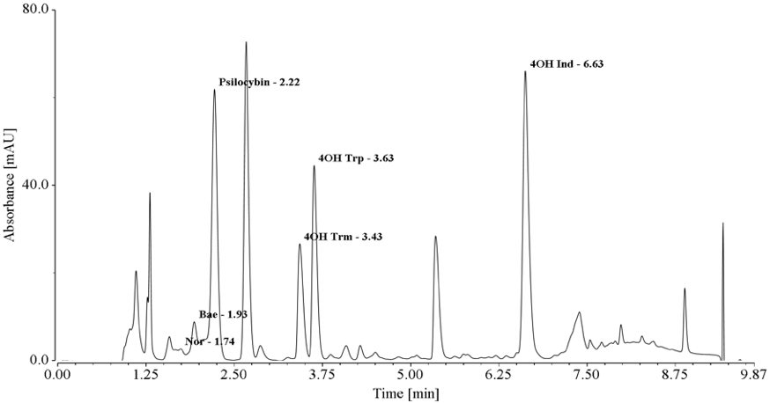

Figure S2. Example chromatogram (280 nm) for HPLC method (1 mL/min) with retention times listed. The data was obtained from a sample of cell-free broth supernatant from an optimized psilocybin production host selected to have major peaks for all relevant metabolites.



Figure S3. Example chromatogram (280 nm) for LC-MS method (0.25 mL/min) with retention times, MS, and MS/MS fragmentation shown. The data was obtained from a sample of cell-free broth supernatant from an optimized psilocybin production host selected to have major peaks for all relevant metabolites.



Figure S4. 4-hydroxytryptophan analysis in copy number library. 4-hydroxytryptophan was quantified based on the standard curve of 5-hydroxytryptophan due to limited commercial availability and high cost of the authentic standard. Error bars represent ± 1standard deviation from the mean of triplicate samples.



Figure S5. 4-hydroxytryptophan analysis in pseudooperon library. Variants are presented in order of decreasing psilocybin production to enable comparison with Figure 2b. 4-hydroxytryptophan was quantified based on the standard curve of 5-hydroxytryptophan due to limited commercial availability and high cost of the authentic standard.



Figure S6. 4-hydroxytryptophan analysis in basic operon library. Variants are presented in order of decreasing psilocybin production to enable comparison with Figure 2c. 4-hydroxytryptophan was quantified based on the standard curve of 5-hydroxytryptophan due to limited commercial availability and high cost of the authentic standard.



Figure S7. Induction sensitivity of pPsilo16 at 37 ˚C from 0 to 6 hours. Error bars represent ± 1standard deviation from the mean of duplicate samples.



Figure S8. Induction point sensitivity analysis for pPsilo16 growing in AMM – Glucose at different inducer concentrations. Error bars represent ± 1standard deviation from the mean of duplicate samples.

Figure S9. Induction point sensitivity analysis for pPsilo16 growing in AMM – Glycerol at different inducer concentrations. Error bars represent ± 1standard deviation from the mean of duplicate samples.

Figure S10. Induction point sensitivity analysis for pPsilo16 growing in LB at different inducer concentrations. Error bars represent ± 1standard deviation from the mean of duplicate samples.



Figure S11. Supplemental data for fed-batch bioreactor study. (a) Measurement of dissolved oxygen (DO), pH, temperature, and agitation rate. (b) Total cumulative glucose and ammonium phosphate dibasic fed. OD600 is also shown for reference. (c) Total cumulative 4-hydroxyindole fed and 4-hydroxyindole feed rate for the bioreactor scale up study. The purple line (feed rate) represents the derivative for the blue line (cumulative amount fed). (d) Total cumulative 4-hydroxyindole fed (blue) compared to psilocybin production (purple) for the bioreactor scale up study. Transient product molar yield (green) shows a maximum molar yield of 60% at roughly 48 hours and a final molar yield of 38% at the end of the scale-up study.

**Bibliography**

Fricke, J., Blei, F., Hoffmeister, D., 2017. Enzymatic synthesis of psilocybin. Angew. Chemie Int. Ed. 56, 12352–12355. https://doi.org/10.1002/anie.201705489

Jones, J. Andrew, Vernacchio, V.R., Lachance, D.M., Lebovich, M., Fu, L., Shirke, A.N., Schultz, V.L., Cress, B., Linhardt, R.J., Koffas, M.A.G., 2015. ePathOptimize: a combinatorial approach for transcriptional balancing of metabolic pathways. Sci. Rep. 5, 11301. https://doi.org/10.1038/srep11301

Xu, P., Vansiri, A., Bhan, N., Koffas, M.A.G., 2012. ePathBrick: A synthetic biology platform for engineering metabolic pathways in E. coli. Biol 1, 256–266. https://doi.org/10.1021/sb300016b